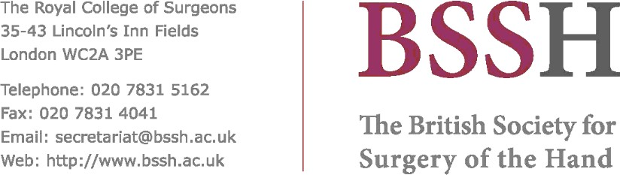

Title / Hospital:
Hand Fellowship (Two Posts)
Chelsea and Westminster Hospital, London
Fellowship Directors: Ms Alice Bremner-Smith / Mr Philip Mathew
Trauma and Orthopaedic Consultants:
Ms Alice Bremner Smith, Mr Philip Mathew, Mr Maxim Horwitz, Mr Rupert Eckersley, Ms
Kate Owers, Mr David Bodansky
Plastic Surgery Consultants:
Mr Gordon McArthur, Ms Gill Smith, Ms Anita Jatan, Ms Effie Katsarma, Mr Tomas Tickunas
Aims / Subspecialist Areas of Interest:
All aspects of hand and wrist trauma
All aspects of elective hand and wrist surgery
Each post has regular commitments with both Orthopaedic and Plastic Surgery Consultants
Period Sponsor: 6-12 months
Career Grade of Applicants: Post FRCS (Plast) / FRCS (Tr & Orth) or equivalent
Extra Information (on-call commitments, research opportunities etc):
One post requires participation in the general Orthopaedic on-call rota (1in 8)
Protected research time is provided
Completion of the BSSH Hand Diploma is encouraged
Start Fellowship Dates: Yearly – August and February start dates
Closing Date for Application: As advertised on NHS jobs website
Interview Date: TBC
Contact Person: Ms Alice Bremner-Smith
Email: alice.bremner-smith@nhs.net
Application Address:
Chelsea and Westminster Hospital
369 Fulham Road
London, SW10 9NH
Tel / Fax:
Website: http://chelwest.nhs.uk
Additional Information:

