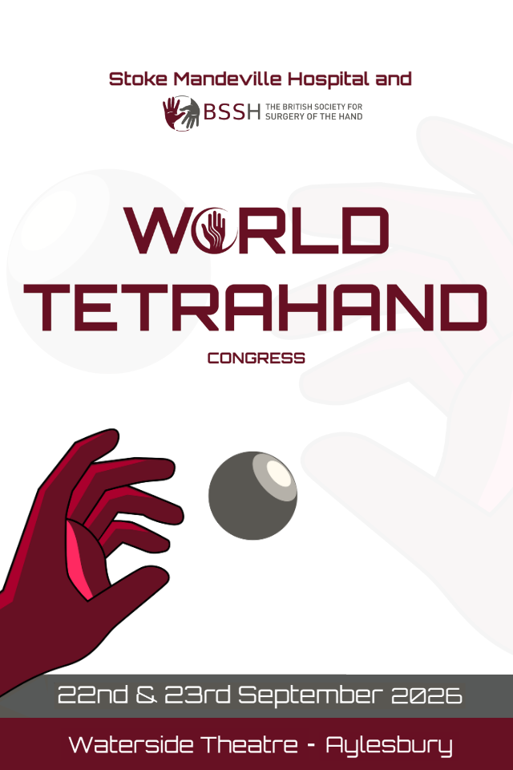

TRADE
OPPORTUNITIES

World Tetrahand Congress

Stoke Mandeville Hospital and the British Society for Surgery of the Hand (BSSH) are excited to invite you to the Aylesbury Waterside Theatre for the World Tetrahand Congress 2026. This prestigious scientific meeting will bring together leading clinicians, researchers, and healthcare professionals in the field of Tetraplegia providing a unique platform for high-level knowledge exchange and innovation.

The National Spinal Injuries Centre (NSIC) at Stoke Mandeville Hospital, founded in 1944 by Sir Ludwig Guttmann, is world-renowned for transforming spinal injury care and inspiring the Paralympic movement. For 80 years, it has led innovation in rehabilitation, surgery, and therapy.

Aylesbury Waterside Theatre has great transport links, is within easy reach of local rail and bus routes as well as London’s airports making it easily accessible for UK and international delegates alike.

Date
Tuesday 22nd - Wednesday 23rd September 2026

Venue
Waterside Theatre, Exchange Street, Aylesbury, Buckinghamshire, HP20 1UG
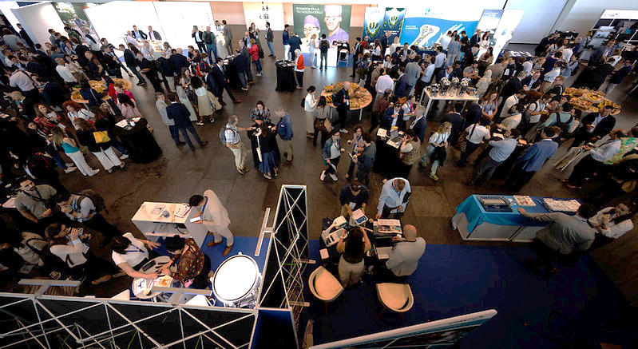

Exhibition floorplan
TBC

Trade Opportunities
This is a two-day meeting taking place from Wednesday 22nd – Thursday 23rd September 2026, where the catering and exhibition will be located in one area. 20 stands are available which will be sold on a first come, first served basis.
Choose from our packages and options below:

OBSIDIAN PACKAGE | £6,000 + VAT
- Top location tabletop stand with access to power
- Direct engagement with delegates and decision-makers
- Full page, full colour, A5 advert in programme
- Recognition as premium sponsor in programme
- Logo and bio on website and app
- Logo displayed on holding slide shown during the meeting
- Meeting registration and catering for 4 representatives

EXHIBITION STAND PACKAGE | £3,000 + VAT
- One tabletop exhibition stand in the main exhibition hall
- Direct engagement with delegates and decision-makers
- Company listing in meeting programme and promotional materials
- Meeting registration and catering for up to 2 representatives
- Access to electrical sockets

Additional sponsorship opportunities

OPTION 1 - Drinks reception sponsorship | £1,500 + VAT
Sponsor the congress dinner drinks reception:
- Advertising of drinks reception on event app, printed programme and website
- Sponsored drinks reception advertised via email to delegates
- Logo displayed on signage advertising drinks reception

OPTION 2 – Meeting WI-FI | £1,500 + VAT
- Choose the username and password for the meeting

OPTION 3 – Refreshments sponsorship | £1,000 + VAT
- Company logo to be displayed during the meeting refreshment breaks

OPTION 4 – Free paper prize sponsorship | £500 + VAT
Sponsor the top free paper of the meeting:
- Prize to be named after sponsor
- Advertising of poster prize sponsorship in promotional material

OPTION 5 – Poster Prize sponsorship | £250 + VAT
Sponsor the highest scoring poster:
- Prize to be named after sponsor
- Advertising of poster prize sponsorship in promotional material

OPTION 6 – Lunchtime symposium | £1,000 + VAT
Hold a session over lunch time on a topic of your choice (2 available)
- Symposium added to the printed programme, event app and website
- 30 minute symposium during lunch break
- Push notification and specific email send to all delegates

OPTION 7 – Lanyards | £1,000 + VAT
- Provide the delegate lanyards for the meeting showing your logo (1 available)

OPTION 8 – Push notification in app | £500 + VAT
- Send a push notification to all delegates

OPTION 9 - Advert | £500 + VAT
- Full-page, full colour advert in A5 printed programme
- Advert in meeting app

TRADE Booking form
World Tetrahand Congress 22-23 September 2026, Aylesbury Waterside Theatre
COMPANY DETAILS
Company name | Click or tap here to enter text.
Contact name  All conference information will be sent to the named contact | Click or tap here to enter text.
Finance department contact  (for invoicing queries) | Click or tap here to enter text.
Company Address  (for invoicing) | Click or tap here to enter text.
VAT Registration Number | Click or tap here to enter text.
Email address | Click or tap here to enter text.
Telephone number | Click or tap here to enter text.
PO number for invoice | Click or tap here to enter text.

TRADE SPONSORSHIP | COST (excl.VAT) | SELECT
Exhibition stand Package  Please state requested stand number: |  | ☐  Click or tap here to enter text.
Option 1 – Drinks reception sponsorship |  | ☐
Option 2 – Meeting WIFI |  | ☐
Option 3 – Refreshments sponsorship |  | ☐
Option 4 – Poster area sponsorship |  | ☐
Option 5 – Poster prize sponsorship |  | ☐
Option 6 – Lunchtime symposium |  | ☐
Option 7 – Lanyards |  | ☐
Option 8 – Push notification in app |  | ☐
Option 9 – Advert |  | ☐
TOTAL SPONSORSHIP TO INVOICE | Click or tap here to enter text.

DETAILS FOR WEBSITE AND PRINTED PROGRAMME
Company name | Click or tap here to enter text.
Contact description  (100 words max) | Click or tap here to enter text.
Company address | Click or tap here to enter text.
Email address | Click or tap here to enter text.
Telephone number | Click or tap here to enter text.
Website | Click or tap here to enter text.
Have you attached/emailed company logo? (yes/no) | Click or tap here to enter text.

Sponsorship and Exhibition Agreement - Terms and Conditions
Payment Terms: 30 days from date of invoice. Please note we cannot confirm stand space until full payment of our invoice has been received.
Cancellation Policy: A refund will be applied if the event is postponed or cancelled. A refund will not be given if the client cancels within 30 days of the event.
Delegate List: Due to GDPR legislation, we no longer provide a printed delegate list. However, you can access this information within the event app.
Please return completed form to secretariat@bssh.ac.uk

