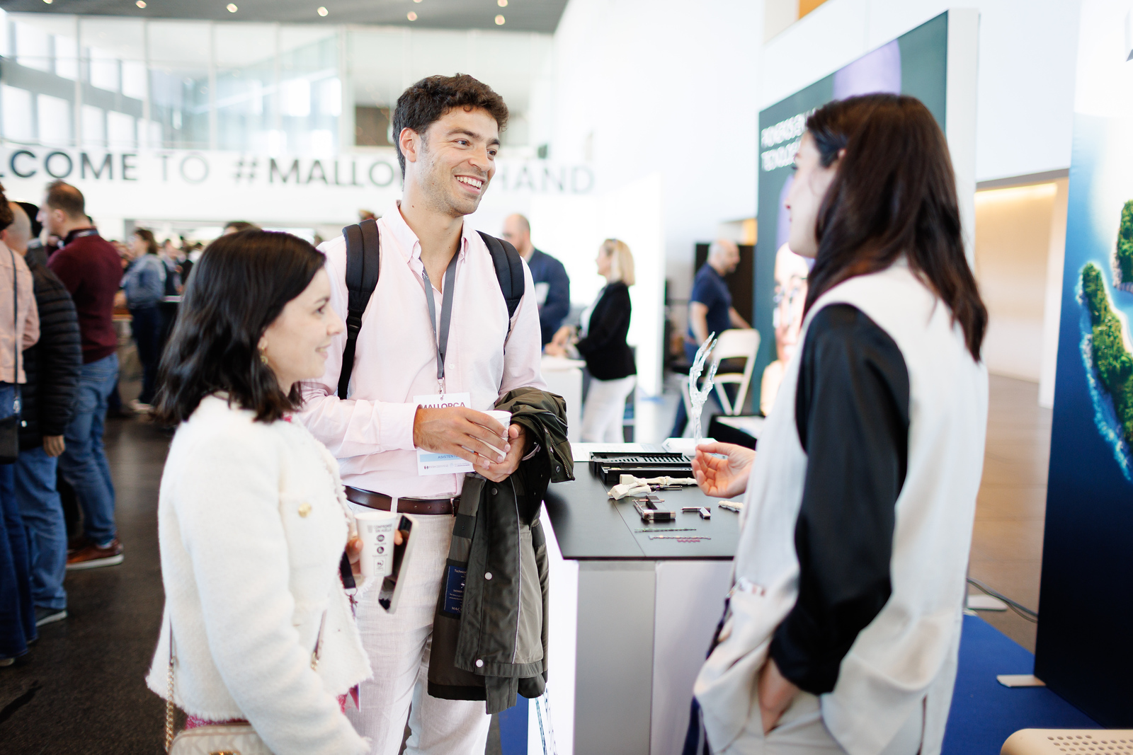

TRADE

OPPORTUNITIES
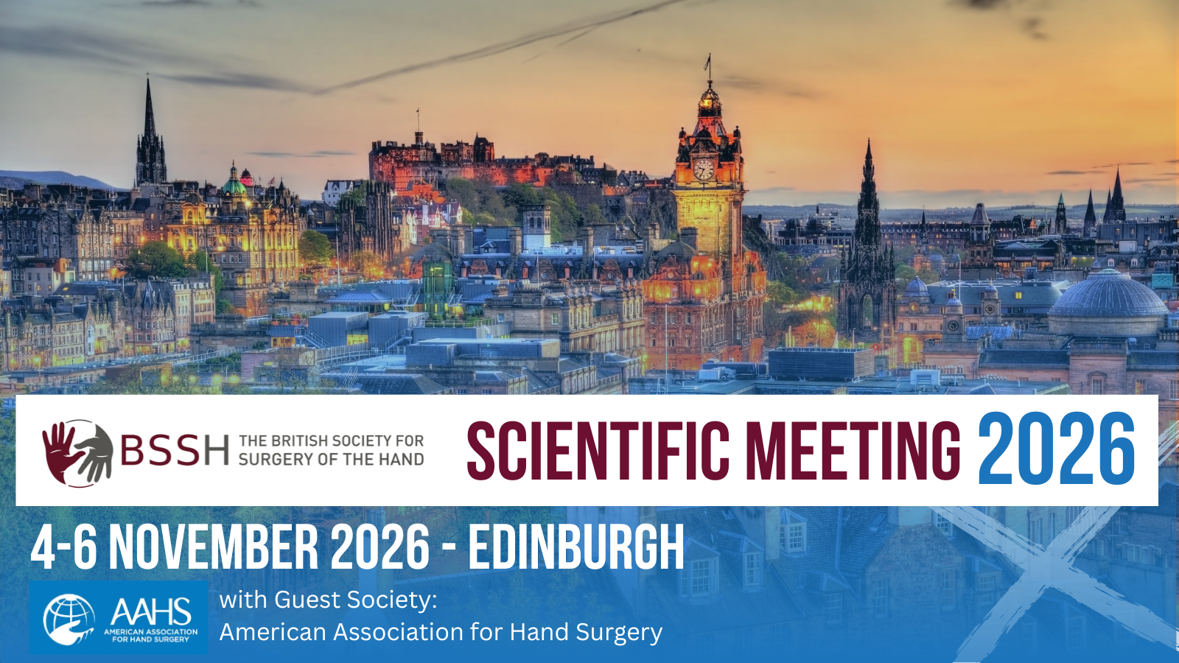

BSSH Scientific Meeting 2026

The British Society for Surgery of the Hand (BSSH) is excited to invite you to its three day scientific meeting in Edinburgh, 4th – 6th November 2026 with Guest Society, American Association for Hand Surgery (AAHS).

2026 will be the first year BSSH have one, larger and longer conference over three days, rather than the historical shorter two day Spring and Autumn meetings. With the increased scientific programme, we expect to see higher delegate numbers and increased networking opportunities.

“Edinburgh, The Historical Capital of Scotland”

As the capital of Scotland, Edinburgh is a breathtaking city that brings visitors from all over the world. Nestled against the backdrop of UNESCO World Heritage architecture, Edinburgh stands as a testament to the perfect blend of history, culture, and modern vibrancy. With multiple car parks within walking distance, two train stations within two miles and only six miles from Edinburgh International Airport, UK and international meeting attendees will find the EICC easy to travel to.

Date
Wednesday 4th – Friday 6th November 2026

Venue
Edinburgh International Conference Centre (EICC)
The Exchange
Edinburgh
EH3 8EE
Scotland

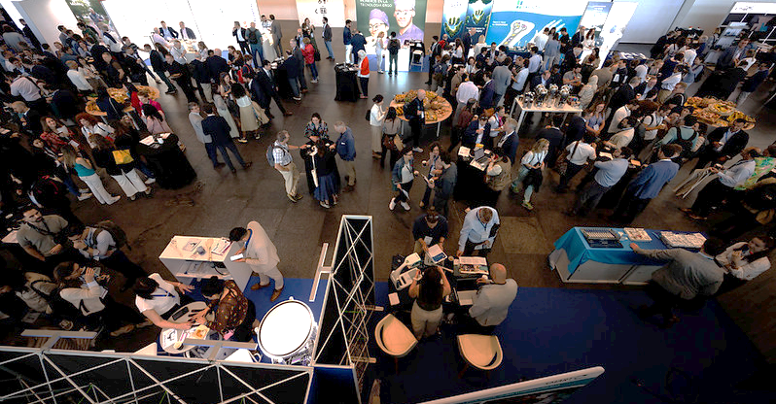

Trade Opportunities
This is a three-day meeting taking place from Wednesday 4th – Friday 6th November 2026, where the catering and exhibition will be located in one area. Stand selection will be in order of booking. An exhibition floorplan will be provided when available.
BESPOKE PACKAGE | POA
We are happy to work with you to create bespoke packages to meet your individual requirements, such as:
- Educational Partnerships
- Workshops
- Sponsoring a specific session
- Pre-meeting workshop on a topic of your choice on the day prior to the main meeting, enjoying 1-2-1 access to delegates
Contact us to discuss your ideas to design an exciting bespoke package or educational partnership.

Or, choose from our packages and options:
3 DAY EXHIBITION STAND PACKAGE | £4,750 + VAT
- One tabletop exhibition stand – table and two chairs included
- Logo and company bio in printed programme and event app
- Logo on website
- Logo on holding slide
- Catering for up to two representatives, including lunch and refreshments during breaks
- 4 way 3 amp power supply included

BSSH DINNER TICKET | £100 + VAT
- Join BSSH faculty and delegates at the black-tie BSSH Scientific Meeting Dinner at the spectacular National Museum of Scotland on Thursday 25th November

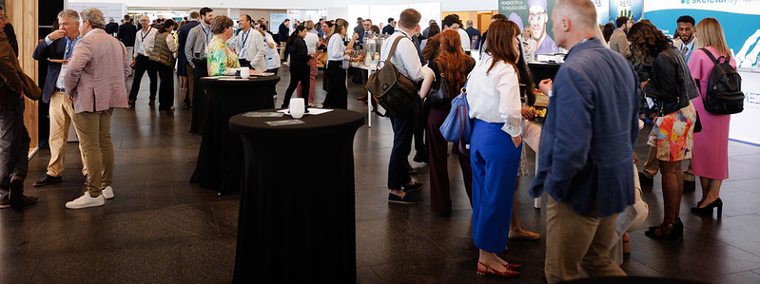

Additional sponsorship opportunities
Educational sponsorship
OPTION 1 – Main session sponsorship | £3,500 + VAT
- Sponsor and take part in a session during the main congress
- Topics to be discussed and agreed
- Sponsorship of session and speaker names displayed in the printed programme and app

OPTION 2 – Lunchtime symposium | £2,000 + VAT
- Symposium added to the printed programme, event app and website
- 45 minute symposium during lunch break
- Three available: Wednesday 4th November, Thursday 5th November, Friday 6th November
- Push notification sent to delegates via event app

OPTION 3 – Breakfast symposium | £1,500 + VAT
- Symposium added to the printed programme, event app and website
- 30-minute symposium prior to main sessions start time
- Two available: Thursday 5th November, Friday 6th November
- Push notification sent to delegates via event app

OPTION 4 – Best Paper Prize sponsorship | £500 + VAT
- Sponsorship of Best Paper from your choice of categories (one sponsor per category):
- Best Nerve Paper
- Best Bone and Joint Paper
- Best Practice Paper
- Best Tendon Paper
- Best Innovation Paper
- Prize to be named after sponsor
- Advertising of paper prize sponsorship in programme and event app
Other sponsorship
BSSH Scientific Meeting Dinner
Thursday 5th November, National Museum of Scotland
Sponsor this black-tie dinner which provides the opportunity to network with up to 400 meeting attendees. Dine amongst the exhibits from the age of dinosaurs to the technology of the future. As a sponsor of this special event, you’ll be supporting the future work of the BSSH to promote and direct development of hand surgery and to foster and co-ordinate education, study and with the ultimate aim of optimising treatments and outcomes for patients.

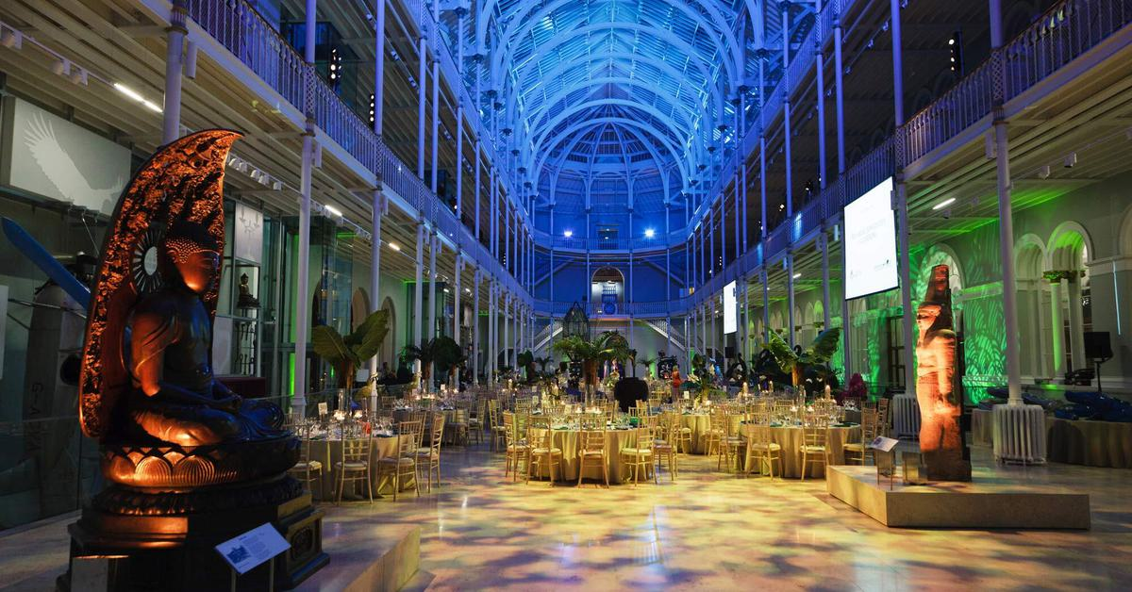  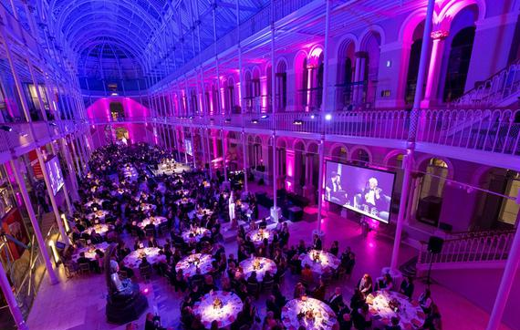  OPTION 5 – Dinner: Headline sponsor | £6,000 + VAT
- A table for 10 people in a prime position on the evening (worth £1200)
- High profile presence at the congress dinner with primary branding opportunities including; logo placement within the stage set alongside your logo on seating plans displayed at the entrance to the venue
- Full page, full colour feature in our event programme distributed to all guests.
- Verbal acknowledgement and on-stage thank you for your support at the event
- Acknowledgement of support in PR about the event
- Acknowledgement across BSSH social media platforms
OPTION 6 – Dinner: Drinks reception | £2,000 + VAT
- Acknowledgement as the welcome drinks sponsor on all event materials and online
- Branding in the welcome drinks reception area with the opportunity to dress the area with your own company pop-up banner and marketing literature
- Two tickets to the congress dinner
- Half page, full colour feature in our event programme
- Acknowledgement and thank you during the welcome speeches
- Support acknowledged on the event webpages and booking site

Standalone Drinks Reception
Wednesday 4th November, Edinburgh Castle
OPTION 7 – Drinks reception sponsorship | £3,000 + VAT
Standalone drinks reception on the evening of Wednesday 4th November, including:
- A glittering drinks reception at the iconic Edinburgh Castle, with panoramic views across the city
- Advertising of drinks reception on event app, printed programme and website
- Sponsored drinks reception advertised via email to delegates and BSSH Members
- Push notification in app during the Wednesday

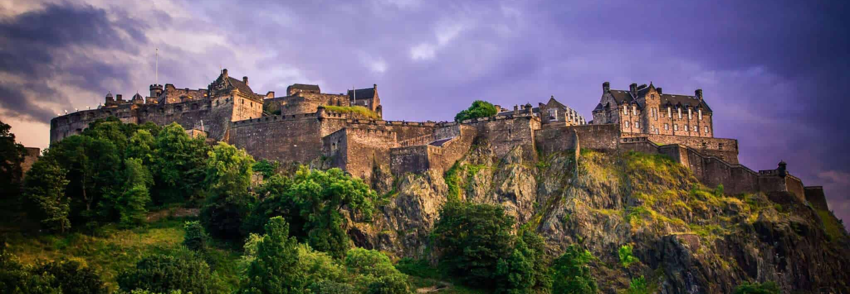
Faculty Dinner
Tuesday 3rd November, Greyfriars Hall
OPTION 8 – Faculty Dinner | £2,500 + VAT
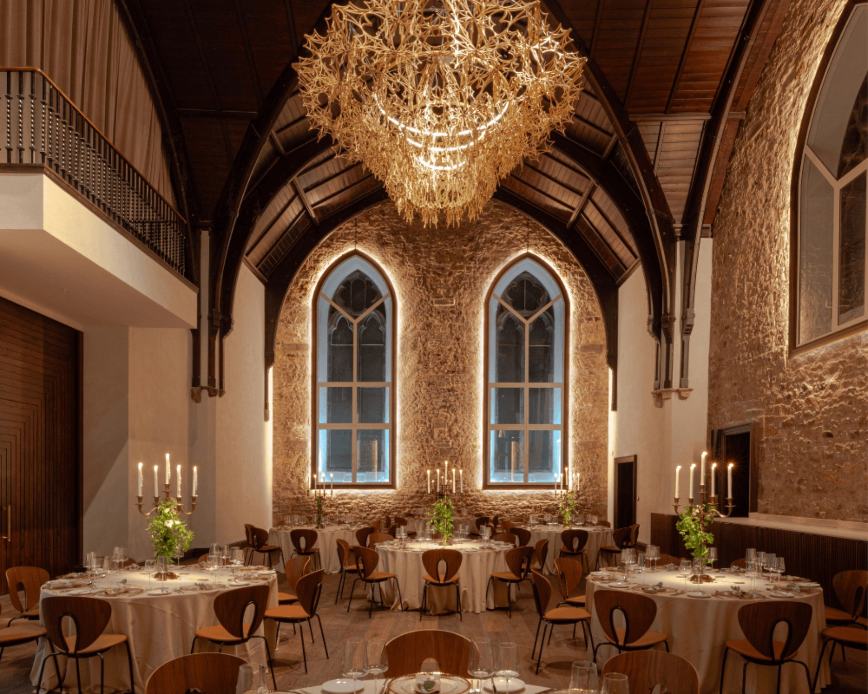
Sponsor and join the BSSH Council and keynote speakers at this faculty dinner being held at Greyfriars Hall, a former medieval church in central Edinburgh.

General sponsorship
OPTION 9 – Meeting Wi-Fi | £1,000 + VAT
- The company will be able to choose the username and password for the meeting

OPTION 10 – Lanyards | £1,250 + VAT
- Lanyards will be provided by the sponsorship company with the corporate logo

OPTION 11 - Full page advert | £1,500 + VAT
- Full-page, full colour advert in A5 printed programme
- Advert in meeting app

OPTION 12 – Push notification in app | £500 + VAT
- Event app push notification sent to all delegates

OPTION 13 – Water coolers | £200 + VAT
- Vinyl graphic applied onto water cooler machine
- Price is per water colour, multiples available in various locations

- Graphics to be provided by sponsor with the following dimensions:
- Top section: 310mm (W) x 225mm (H)
- Bottom section: 590mm (W) x 515mm (H)

OPTION 14 – High bistro tabletops | £125 + VAT
- Vinyl graphic applied onto bistro table tops
- Price is per table top, multiples available within exhibition and communal areas
- Graphics to be provided by sponsor: 550mm diameter

TRADE Booking form
BSSH Scientific Meeting 2026 – 4-6 November 2026, Edinburgh
COMPANY DETAILS
Company name | Click or tap here to enter text.
Contact name  (for conference information) | Click or tap here to enter text.
Finance department contact  (for invoicing queries) | Click or tap here to enter text.
Company Address  (for invoicing) | Click or tap here to enter text.
VAT Registration Number | Click or tap here to enter text.
Email address | Click or tap here to enter text.
Telephone number | Click or tap here to enter text.
PO number for invoice | Click or tap here to enter text.

TRADE SPONSORSHIP | COST (excl.VAT) | SELECT
Exhibition stand package | £4,750 | ☐
BSSH Dinner tickets (state quantity) | £100/each | Click or tap here to enter text.
Option 1 – Main session sponsorship | £3,500 | ☐
Option 2 – Lunchtime symposium | £2,000 | ☐
Option 3 – Breakfast symposium | £1,500 | ☐
Option 4 – Paper Prize sponsorship (state topic/s) | £500/each | Click or tap here to enter text.
Option 5 – Dinner: Headline sponsor | £6,000 | ☐
Option 6 – Dinner: Drinks reception sponsorship | £2,000 | ☐
Option 7 – Drinks reception sponsorship – Edinburgh Castle | £3,000 | ☐
Option 8 – Faculty dinner sponsorship | £2,500 | ☐
Option 9 – Meeting WIFI | £1,000 | ☐
Option 10 – Lanyards | £1,250 | ☐
Option 11 – Printed programme advert | £1,500 | ☐
Option 12 – Push notification in app | £500 | ☐
Option 13 – Water cooler (state quantity) | £200/each | Click or tap here to enter text.
Option 14 – High bistro table tops (state quantity) | £125 | Click or tap here to enter text.
TOTAL SPONSORSHIP TO INVOICE | Click or tap here to enter text.

DETAILS FOR WEBSITE AND PRINTED PROGRAMME
Company name | Click or tap here to enter text.
Contact description  (100 words max) | Click or tap here to enter text.
Company address | Click or tap here to enter text.
Email address | Click or tap here to enter text.
Telephone number | Click or tap here to enter text.
Website | Click or tap here to enter text.
Have you attached/emailed company logo? (yes/no) | Click or tap here to enter text.

Sponsorship and Exhibition Agreement - Terms and Conditions
Payment Terms: 30 days from date of invoice. Please note we cannot confirm stand space until full payment of our invoice has been received.
Cancellation Policy: A refund will be applied if the event is postponed or cancelled. A refund will not be given if the client cancels within 30 days of the event.
Delegate List: Due to GDPR legislation, we no longer provide a printed delegate list. However, you can access this information within the event app.
Please return completed form to secretariat@bssh.ac.uk

