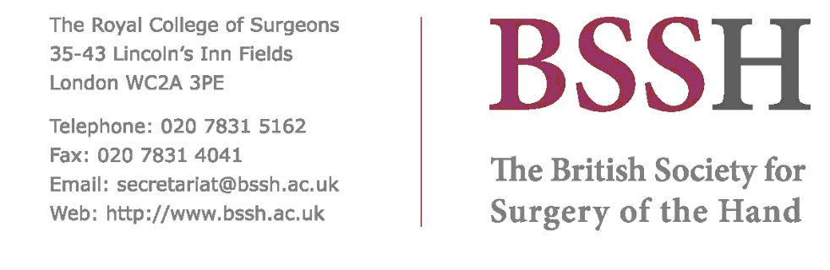

APPLICATION FORM FOR EXHIBITION
BSSH SPRING SCIENTIFIC MEETING
3-4 MAy 2018
HILTON CARDIFF, KINGSWAY, CARDIFF, CF10 3HH

Company Name:
Company Address:
Telephone:
Fax:
E-Mail:
Position held:
Name(s) of Personnel Attending

We would like a power point. Yes/No*
(one 13 amp power point and electricity is included in the exhibition fee, exhibitors MUST provide extension leads)

A table is required Yes/No*

We expect to display the following products:

We wish to participate at this meeting and would like to reserve a stand:

We confirm that the stand size will not exceed the booked size.

Stand size: | 2 m x 1 m  £800.00 + VAT | 3 m x 1 m  £1,150.00 + VAT

Signed: | Date:

EXHIBITION SPACE WILL NOT BE BOOKED UNLESS FULL PAYMENT IS RECEIVED.
The organisers do not accept responsibility for loss or damage to exhibitors’ property during the exhibition.
NOVEMBER 2017

