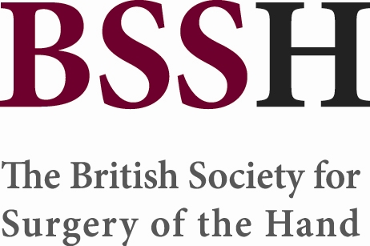

Chair, Education and Training Committee
(January 2022 – December 2024)

The BSSH is seeking expressions of interest for the position of Chair of the Education and Training Committee. The role is for a three year term from January 2022 – December 2024. Whilst the role itself does not begin until January 2022, we would anticipate there being an induction period of around 3-6 months this year, overlapping with the current Chair.

Closing date:
Please complete and return the attached application form to secretariat@bssh.ac.uk by 28th February 2021.

Purpose of the Committee
The Education and Training Committee exists to further the education and training agenda of the British Society for Surgery of the Hand (BSSH). We take this to mean the inception, development, promotion and maintenance of activity related to continuing professional development both of trainee and established consultant surgeons and associated professionals with an interest in Hand Surgery.

Eligibility and selection criteria
The Chair should be a full member with previous experience on a BSSH committee.

Shortlisting will be undertaken by the Education and Training Committee and interviews will be held when there is more than one suitable candidate.

The interview panel will be composed of the current BSSH committee Chair, a committee representative, a BSSH Council Trustee or Officer Representative and another committee Chair.

The Chair’s duties include
- Leading and helping to develop the BSSH Education and Training Strategy
- Co-ordinating the various roles of the Committee, setting projects, tasks and deadlines.
- Having oversight of the committee’s projects and activities
- Chairing Committee meetings twice each year in March and September
- Attendance and reporting at Council meetings 2-3 times each year
- Reviewing requests for course badging by the BSSH
- Liaison with the secretariat regarding Committee membership and appointments
- Liaison with BOA, BAPRAS and RCS concerning revalidation and recertification

General Responsibilities of the Committee

- Promotion and support of the education and training of all Hand Surgeons and associated professionals with an interest in Hand Surgery.
- Developing opportunities to optimise training and mentoring in Hand Surgery.
- Judging and awarding the Stack Fellowship, the BSSH Educational Grant, the BSSH Education and Travel Bursary, the Medical Student Elective Bursary, and the Educational Presentation Prize.
- Awareness of issues of affecting training; bringing ideas, opinions and articles to the attention of other members for discussion.
- Completing work-in-progress in good time for the thrice-annual Council meetings

Working methods
- Email and telephone whenever possible- response within 7 days to 10 days excepting when on leave.
- Meetings (face to face and virtual) twice yearly, March and September to allow preparation for presentation at the subsequent council meeting
- Meeting times and venue to be set 1 year in advance

Current Projects allocated to Committee Members
- Implementing a Coaching and Mentoring Training programme for hand surgeons
- Organising the inaugural BSSH Visiting Fellowship
- Updating the BSSH patient information leaflets
- Expanding the BSSH’s Educational role with GPSIs and MSK Physios etc by creating training materials including e-learning style videos

Name
Email address
Town/City
Please confirm you are a full Member of BSSH
Year became Member of BSSH
Have you served on any BSSH Committees – please list committees with dates
How many BSSH Scientific meetings have you attended during 2017 - 2020 inclusive?
Particular areas of expertise in Hand Surgery
Organisational skills (20 word max)

Other skills beneficial to Education and Training Committee organisation
(20 word max)

Personal statement (250-300 words max)

Do you have the time available for this commitment – please list any other significant commitments during January 2022 – December 2024 (with dates) – e.g. clinical/medical director, roles with other specialist societies

Please email form back to Ruth Neave at secretariat@bssh.ac.uk
By 28th February 2021.

