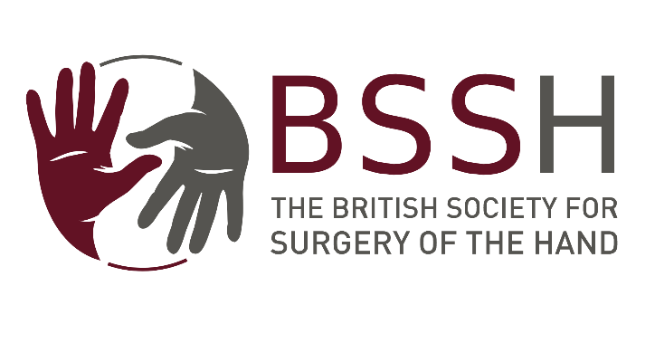 | Application for Medical Student Bursary  Open to BSSH Student Members Only

Full Name:
Date of Birth: | Current Address:
Email:
Tel No:
Medical School:
Current year at Medical School:

Address of Department and institute where elective will take place:

Name of Clinical supervisor/Contact for elective:
Date of Visit:
Length of Visit:

Visit details i.e. Details of the department you will be visiting. What do you hope to learn during the period. What exposure will you have to Hand Surgery?

How will the bursary be used (including estimated costs)?

How will this elective influence your career after qualification?

Education and Qualifications:

Name of current Clinical Tutor/Supervisor:
Contact Details:

Declaration:
I, the undersigned, hereby declare that any money received by me from the British Society for Surgery of the Hand for the purpose of this bursary will be solely for the travelling expenses detailed above.

Signed: Date:

Print name in Capitals:

Closing dates for application are 31st January, for awards in March/April,

Please note:
This award will only be awarded to BSSH Student Members.
The award will not be made retrospectively (except in exceptional circumstances).

The successful candidates will be contacted by email.

The elective must be completed within 18 months of the bursary being awarded
Successful applicants will be required to submit a short written report to the Education and Training Committee of the Society within 2 months of completion of the elective. The report can be in writing, as an infographic or a short video. This will be displayed on the BSSH website to guide future students.

Please submit the form electronically to secretariat@bssh.ac.uk

Student Members refers to undergraduates, or medical students with an interest in hand surgery. The annual subscription is £25.00 which includes online access to the Journal of Hand Surgery (European volume).

