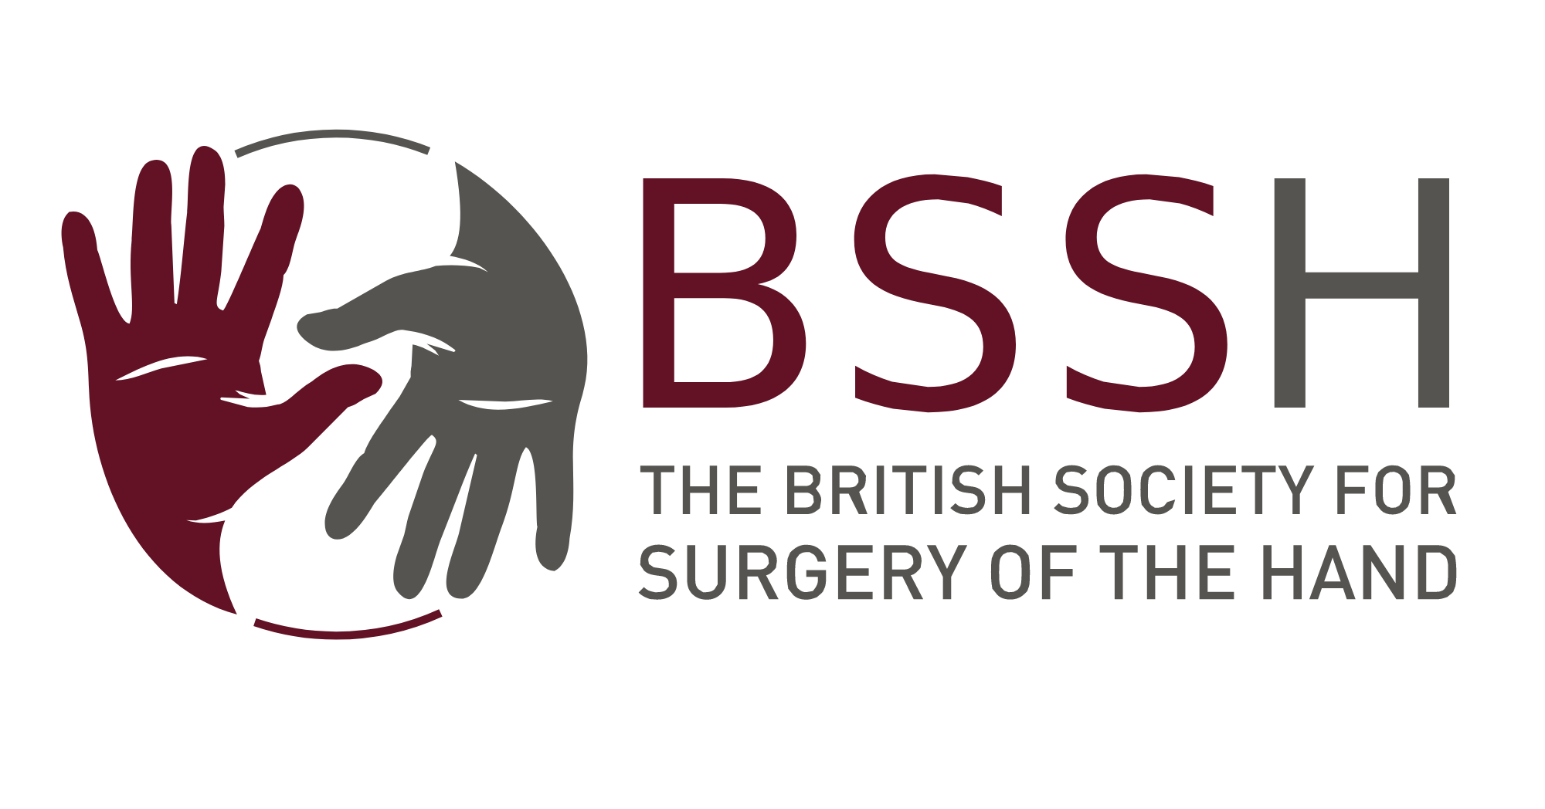 | Application Form  Educational Grant  Up to £5,000.00  Open to BSSH members only

Personal Details
Full Name:
BSSH member since:  (year joined) | Current Address:
Email: | Current Address:
Tel No: | Current Address:

Title of Project:
Brief Synopsis (50 words):

Start Date for project: | End Date for project:
Amount Requested:

Description of Project (500 words):

Estimated Costs:

Sources of Other Funds:

Will the final project be commercial and if so how will profits be dispersed?

Declaration:
I, the undersigned, hereby declare that any money received by me from the British Society for Surgery of the Hand for the purpose of this bursary will be solely for undertaking the project detailed above.

Signed: …………………………………………………………………………………………….. Date: ………………………

Print name in Capitals: ……………………………………………………………………………………………………………..

Closing date for application 31st July for award in autumn annually. The successful candidates will be contacted by email. For larger awards the applicant may be asked to present their application to council.

Successful applicants will be required to submit a short written report to the Education Committee of the Society within 2 months of completion.

Please submit the completed form and an abridged CV electronically to secretariat@bssh.ac.uk

