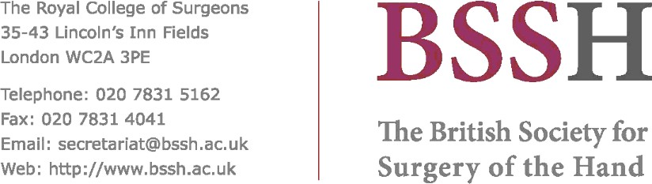

Title / Hospital: Royal Berkshire NHS Foundation Trust
Fellowship Director: Miss Claire Middleton
Consultants: Claire Middleton
David Clarke
Natasha Picardo ( locum)
Aims / Subspecialist Areas of Interest:

Common: Hand and wrist surgery, acute hand and wrist trauma, post-traumatic hand, scaphoid fracture surgery, chronic wrist pain, rheumatoid arthritis and osteoarthritis surgery, finger joint replacement arthroplasty, peripheral nerve surgery, Dupuytren surgery, tendon surgery acute and reconstructive, sports injuries

Less common: Kienbock’s disease surgery, carpal instability surgery
Period Sponsor: 1 year
Career Grade of Applicants: Senior Orthopaedic registrars or post CCT applicants who hold the FRCS (Tr & Orth)
Extra Information (on-call commitments, research opportunities etc):

Participation in the general orthopaedic trauma on-call rota including nights. Clinical research and service improvement opportunities.
Start Fellowship Dates: April 2024 - October 2024
October 2025 - October 2026
Closing Date for Application: N/A
Interview Date: TBC
Contact Person: Claire Middleton
Email: claire.middleton@royalberkshire.nhs.uk
Application Address:

Royal Berkshire Hospital, London Road, Reading, Berkshire RG1 5AN
Tel / Fax: 0118 322 5111
Website: www.royalberkshire.nhs.uk
Additional Information:

